AWS EC2 Lab

Creating a webserver

Marcello Novak | CCNP

***Purpose***

This lab dealt with the creating and configuring an Amazon EC2 webserver. The purpose of a server like this is to test versions of products from companies to see if everything works. What will be accomplished in the end is the creation of a webserver, with a linux machine, that is publicly accessible.

***Screenshots***



The webserver while active.

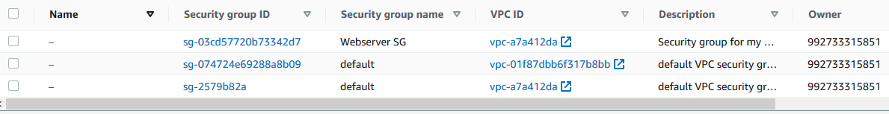

Security Groups for the webserver.

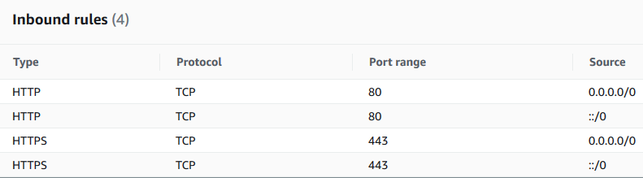

Inbound rules…

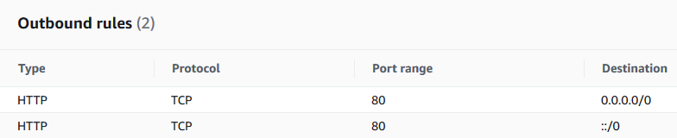

Outbound rules…

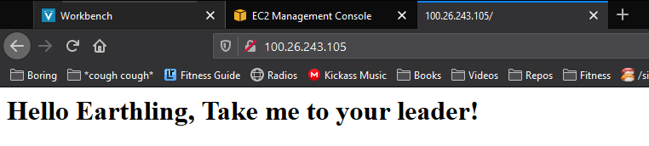

The completed webpage

***Problems***

Like my second AWS lab, this went smoothly as well. I really didn’t find any major difficulties, besides some minor typos in the end. The only real bump was redoing the machine because I forgot to reload the webpage the first time around, but that really wasn’t any different than the first time around, so it’s no issue.